Professor Akwanya, Amechi Nicholas
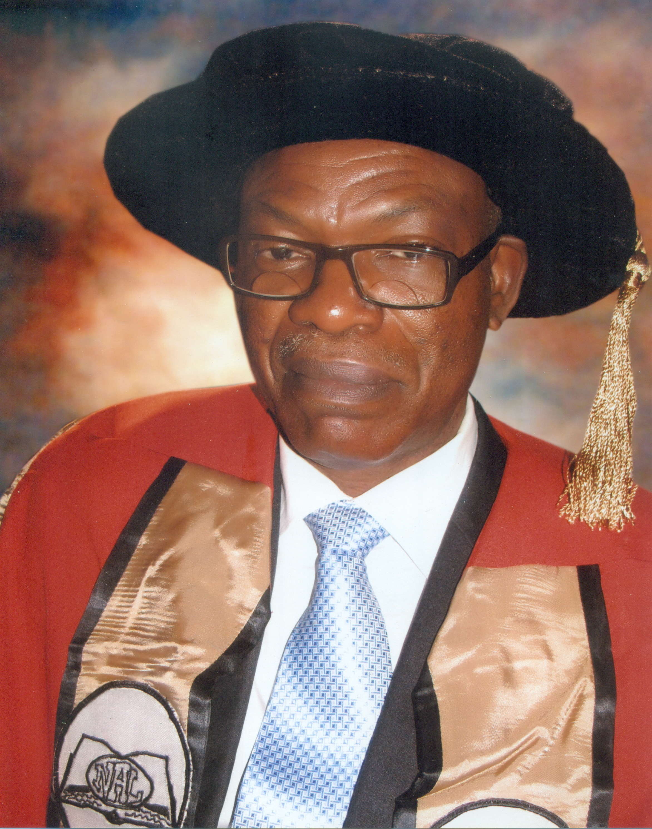
Faculty/Department:
Faculty of Arts
Department of English and Literary
Studies
Designation:
Professor of English & Literary Studies
Email Address:
amechi.akwanya@unn.edu.ng
nickakwanya@gmail.com
Telephone: 234 803 564 1732
Brief Biography
Rev. Fr Professor Amechi Nicholas Akwanya (FNAL, FIIA) has served as the Dean of the School of Postgraduate Studies, University of Nigeria, Nsukka and several times as Head, Department of English and Literary Studies of the University. He is a Professor of English and Literary Studies. After his Bachelor of Divinity (Urban University, Rome, 1980), he studied in the Republic of Ireland, where he obtained a Bachelor of Arts (1985), M.A. (1986), and Ph.D. (1989) and joined the University of Nigeria in 1991, attaining the rank of a Professor in 1999. His research interests include comparative literature, African literature, literary discourse analysis and literary theory, and the phenomenology of language; and he has made major contributions in these areas through full-length books like Semantics and Discourse: Theories of Meaning and Textual Analysis; Verbal Structures: Studies in the Nature and Organisational Patterns of Literary Language; Discourse Analysis and Dramatic Literature; Language and Habits of Thought; Literary Criticism: From Formal to Questions of Method; Fifty Years of the Nigerian Novel 1952-2001 under joint authorship with Dr Virgy Anohu, as well as numerous journal articles in international journals. He teaches courses related to these research areas at the undergraduate and postgraduate levels and supervises Doctorate students. He is also the author of several creative works, including Orimili, a novel in the Heinemann African Writers Series (1991), which was shortlisted for the Commonwealth Best First Book Award (1992), and three collections of poems. He gave the 17th Professorial Inaugural Lecture of the University of Nigeria on 28 February 2007, entitled English Language Learning in Nigeria: In Search of an Enabling Principle. Rev. Fr Professor Akwanya is an active researcher and writer, with more than 120 items to his name. He is the founder of Africa and World Literature: University of Nigeria Journal of Literary Studies and presently the editor of Okike: An African Journal of New Writing founded by the renowned Chinua Achebe.
Area of Specialization
Discourse theory/ discourse studies, literary theory and criticism, phenomenology of language, African & European literatures, Semantics.

Courses Taught
- European Continental Literature
- Studies in Drama
- Modern Literary Theory
- African Poetry
- History of Theatre: Aeschylus to Shakespeare
- European Theatre since Ibsen
- English Literature Survey: the Beginnings
- Semantics
- History of the English Language
- History of Criticism
- Modern Discourse Analysis
- Greek and Roman Literatures
- Linguistics and the Teaching of Literature
- Major Strands in Literary Criticism
- Issues in Comparative Literature
- Discourse Theory
- English Poetry
- English Drama
- Modern British Literature
- Comparative Studies in Poetry
- Comparative Studies in Drama
- Studies in African Drama
- Philosophy of Literature

Other Scholarly Activities
- Dean of the School of Postgraduate Studies, University of Nigeria, Nsukka Head, Department of English & Literary Studies, University of Nigeria 2011-2013
- Head, Department of English & Literary Studies, University of Nigeria 2002-2005
- Coordinator, Sub-Department of Dramatic Arts, 1998-2000
- Editor, Okike: An African Journal of New Writing
- Editor, Book of Readings, Faculty of Arts, University of Nigeria Chinua Achebe Annual Lecture Member, 2012
- Guest Editor, Nsukka Journal of the Humanities, vol 24, No. 1, 2016 Edition
- Member, Nigerian Association for Semiotic Studies;
- Fellow of the Institute of Industrial Administration;
- Fellow, Nigerian Academy of Letters
- Member, Publications Committee, Nigerian Academy of Letters
- Fellow, Nigerian Academy of Letters
- Chairman, University of Nigeria Senate Calendar Editorial Board
- Reviewer, Journal of Languages and Culture
- http://www.academicjournals.org, 2013 -
- Reviewer, International Journal of Scientific Research http://www.ijsrpub.com/ijsrk 2013 -
- Editor, AWL: Africa and World Literature – University of Nigeria Journal of Literary Studies, Nsukka, 2000 – 2012
- Also served two terms as University of Nigeria Orator;
- Crafted the Current Academic Programme, Department of English and Literary Studies, approved by UNN Senate in 2012.
Current Research and Publications

Book Project: Currently work is ongoing on a new book to be entitled, ‘Very Busy Pathway to the Stream: Chinua Achebe’s Literary Legacy’
.
- A.N. Akwanya. Literary Criticism: From Formal to Questions of Method. Nsukka, Nigeria: University of Nigeria Press, 2007.
- Akwanya, Amechi N. ‘Eros, Thanatos, and Captive Lives in Federico Garcia Lorca’s Blood Wedding’. The Criterion: An International Journal in English, Volume 7, Issue 2 (April 2016). 374-384. www.the-criterion.com.

Akwanya, Amechi N. ‘The Wind’s Talk: Spectres in T.S. Eliot’s The Family Reunion. IOSR Journal Of Humanities And Social Science (IOSR-JHSS). Volume 21, Issue 2, Ver. VII (February 2016). 62-70. www.iosrjournals.org. DOI: 10.9790/0837-21276270

Akwanya, Amechi N. ‘The Superman as Master Narrative in Wole Soyinka’s Season of Anomy’. Sage Open. sgo.sagepub.com (October-December 2015): 1–9. DOI: 10.1177/2158244015611450.

Akwanya, Amechi N. ‘Poetry’s Two Estates and Shared Meanings: the Grounds of Comparative Literature’. Journal of Studies in Social Sciences. Volume 13, Number 1 (2015): 35-53. http://infinitypress.info/index.php/jsss/article/view/1197/537

Amechi N. Akwanya. ‘The Self as a Linguistic Event: Discourse Functions in the Poetry of Fernando Pessoa’. IOSR Journal Of Humanities And Social Science (IOSR-JHSS). Volume 20, Issue 8, Ver. I (August. 2015). 44-50. www.iosrjournals.org. DOI: 10.9790/0837-20814450.

Amechi N. Akwanya. ‘Literature and the Possibilities of Language Function’. Journal of Studies in Social Sciences. Volume 11, Number 2 (2015) 233-254

Amechi N. Akwanya. ‘A View of Tragedy: The Mythological Image in the Poetry of Paul Celan’. IOSR Journal Of Humanities And Social Science (IOSR-JHSS). Volume 20, Issue 3, Ver. III (Mar. 2015). 102-109. www.iosrjournals.org. DOI: 10.9790/0837-2033102109.

A.N. Akwanya. ‘African Languages, Translation and Expansion of Language Functions: The Case of Igbo’. Journal of Tourism and Heritage Studies. Vol. 3, No.1 (2014): 1-17.

Amechi N. Akwanya. ‘The Interpreted World’s Resistance to Perishing in Wole Soyinka’s Aké’. BEST: International Journal of Humanities, Arts, Medicine and Sciences (BEST:IJHAMS). Volume 2, Issue 11. November 2014. 11-22. www.bestjournals.

A.N. Akwanya. ‘Function, Deliberative Action, and Struggle in Things Fall Apart and Arrow of God’. Okike: An African Journal of New Writing 52 (2014): 104-123. http://okikeafricanjournal.org.
- Amechi N. Akwanya. ‘The World’s Far Side: Being and It’s Other in the Poetry of Boleslaw Lesmian’. IOSR Journal Of Humanities And Social Science (IOSR-JHSS). Volume 19, Issue 7, Ver. VII (July. 2014), PP 88-96 www.iosrjournals.org. DOI: 10.9790/0837-19778896
- Amechi N. Akwanya. ‘Aristotle’s Double Bequest to Literary Theory and Two Discourses of Truth’. International Journal of Humanities and Social Sciences (IJHSS). Vol. 3, Issue 4, (July 2014). 35-46. www.iaset.us.
- Akwanya, Amechi Nicholas. ‘Duty and Freedom in T. Obinkaram Echewa’s The Land’s Lord: A Sartrean Assessment’. Journal of Studies in Social Sciences. Volume 6, Number 2 (2014). 13-33. http://infinitypress.info/index.php/jsss/index.
- Akwanya, A.N. (2013). ‘Why Did He Do It? Chinua Achebe’s Spectacular Heroes’. Okike: An African Journal of New Writing 50: pp. 104-123.
- Akwanya, Amechi Nicholas. ‘Need that throbs at the heart: Solidarity in Chinua Achebe’s Anthills of the Savannah’ International Journal of English and Literature. Vol. 4(10), pp. 486-494, December, 2013 DOI: 10.5897/IJEL2013.0496 ISSN 2141-2626 © 2013 Academic Journals http://www.academicjournals.org/IJEL.
- Akwanya, Amechi Nicholas (2013). ‘No Longer at Ease, The Crippled Dancer and the Labour of Sisyphus’. Quest Journal of Research in Humanities and Social Science (JRHSS). www.questjournals.org 1.1, pp. 07-15
- Akwanya, Amechi Nicholas (2013). ‘The Power of the Unknown in Chinua Achebe’s Arrow of God’. International Journal of Humanities and Social Science Invention. www.ijhssi.org 2.8, pp. 35-42
- Akwanya, Amechi Nicholas (2013). ‘Angst in Rainer Maria Rilke’s Duino Elegies’. IOSR Journal of Humanities and Social Science (IOSR-JHSS).13. 6, pp 34-41. Web.
- Akwanya, Amechi Nicholas (2013). ‘The Father's Power in Breitbach's Report on Bruno and Achebe's A Man of the People’. CLCWeb: Comparative Literature and Culture 15.1. Web.
- Akwanya, A.N. (2013). ‘Reading, Text, and the Metaphors of Perception’. In Philosophy Study. Vol.3 No.1, pp. 76-84.
- A.N. Akwanya. ‘Chinua Achebe’s Legacy: Custodianship at the University of Nigeria. JOTRED: Journal of Technological Research and Development, 2.1. February 2013. 145-148
- Akwanya, A.N. (2012). Visitant on Tiptoe and Other Poems. Ibadan, Nigeria: Kraft Books. ISBN978-91808-7-5
- Akwanya A.N. (2011).’ Higher Education and the Challenge of Integral Human Development’. Journal of Arts and Human Sciences Vol4, No.1 pp. 25-42.
- Akwanya, A.N. (2006) ‘The Review Essay.’ Essays and Literary Concepts in English. Ed. Sam Onuigbo (2006). Nsukka: Afro-Orbis Publications. ISBN 978-365-99-3-6, pp. 45-64.
- Akwanya, A.N. (2012) ‘Art and the Artist in the Nigerian Novel’ in O. Udechukwu and Chika Okeke-Agulu (2012). Ezumeezu: Essays on Nigerian Art and Architecture. Glassboro, New Jersey. ISBN 978-1-938598-05-2, pp. 11-22.
- Akwanya, A.N. (2012) ‘Demas Nwoko and the Protean Imagination.’ With C. Onuora. Ezumeezu: Essays on Nigerian Art and Architecture. Ed. O. Udechukwu and Chika Okeke-Agulu (2012). Glassboro, New Jersey. ISBN 978-938598-05-2, pp 155-164.
- Akwanya, Amechi and Virgy Anohu (2012). Fifty Years of the Nigeria Novel,1952-2001. Lambert Academic Publishing. ISBN 978-3-659-2300-6
- Akwanya, A.N. (2010) ‘Chinua Achebe’s Things Fall Apart: Scenery and Two Accounts of Genre’. New Studies on Language, Literature and Society: A Festschrift in Honour of Professor Aliyu Mohammed at Sixty-Five. Ed. Idris O.O. Amali, Adebayo A. Joshua, and Amina Bashir (2010). Zaria: Ahmadu Bello University Press, ISBN 978-125-930-2, pp. 296-310.
- Akwanya, A.N. (2009). ‘Nigeria’s Development Profile: From ICT to Language, Literature, and Ethics.’ Language Literature and Information Communication Technology. S.Y. Atabo (2009). Ankpa: School of Languages Publication ISBN 978-49741-0-3, 2009. 1-16
- Akwanya, A.N. (2008). ‘Language to Achieve the Global Millennium Goals.’ The Muse: A Literary Journal for Creative and Critical Writing at Nsukka No.36, pp.2-13.
- Akwanya, A.N. (2007). Moments: A Collection of Poems. Enugu, Nigeria: New Generation Books. ISBN 978-2900-67-2
- Akwanya, A.N. (2007). ‘Marginalia of Scientific Semantics: The Question of the Aesthetic Object.’ JONASS: A Publication of the Association for Semiotic Studies Vol.1 Nos.1&2, pp. 33-42.
- Akwanya, A.N. (2007). ‘Historicity in the History of Literary Criticism’. The Muse No. 35, pp. 21-29.
- Akwanya, A.N. (2006). ‘Basic Literary Concepts.’ Essays and Literary Concepts in English. Ed. Sam Onuigbo (2006). Nsukka: Afro-Orbis Publications. ISBN 978-365-99-3-6, pp. 103-124.
- Akwanya, A.N. (2006) ‘Research Paper and Thesis Proposal.’ Ed. Sam Onuigbo. (2006). Nsukka: Afro-Orbis Publications, ISBN 978-365-99-3-6, pp. 65-100.
- Akwanya, A.N. (2006) ‘Chinua Achebe’s No Longer at Ease and the Question of Failed Expectations.’ Okike: An African Journal of New Writing. No. 48, pp. 73-101.
- Akwanya, A.N. (2005). Pilgrim Foot: A Collection of Poems. Enugu, Nigeria: New Generation Books. ISBN978-2900-47-8
- Akwanya, A.N. (2005). ‘The Arts and Us.’ The Muse, Vol.31, pp.11-25
- Akwanya, A.N. (2005). ‘Literary Studies in Nigeria: An Advanced State of Crisis.’ CALEL: Currents in African Literature and the English Language, Vol.3 No.1, pp. 148-164
- Akwanya, A.N. (2005) ‘The Nigerian Priest and the Evangelization Strategy of the Early Missionaries.’ Witnessing Christ in Contemporary Nigeria. Ed. A.N. Odoemena (2005). Port-Harcourt: IHBC-CIWA Publication, ISBN 978-38386-8-7, pp. 52-71
- Akwanya, A.N. (2003). ‘Criticism and the Need for New Modes of Argument.’ Africa and World Literature: University of Nigeria Journal of Literary Studies, Vol.3, pp.1-6
- Akwanya, A.N. (2003) ‘Semantics and Literary Studies.’ Nsukka Journal of the Humanities Vol.13, pp. 230-247.
- Akwanya, A.N. (2001). ‘Literature and the Cultural/Nationalist Question.’ Africa and World Literature: University of Nigeria Journal of Literary Studies, Vol.2, pp.1-6.
- Akwanya, A.N. (2001). ‘Dramatic Theory and Theatre Practice.’ Africa and World Literature: University of Nigeria Journal of Literary Studies, No.1, pp.1-16.
- Akwanya, A.N. (2001) ‘Poststructuralist Theories and the Criticism of the Nigerian Novel.’ Ed. A.A. Akpuda (2001). Reconstructing the Canon: Festschrift in Honour of Professor Charles E. Nnolim. Owerri: Treasure Books, ISBN 978-35847-1-5 pp. 311-324.
- Akwanya, A.N. (2001) ‘Orthodoxy in African Literary Criticism: Need for a New Beginning.’ Okike: An African Journal of New Writing. No 45, pp.19-31.
- Akwanya, A.N. (2001) ‘Literature in Easter Nigeria: The Last 40 Years’ In Onuora Ossie Enekwe (2001). Harvest Time: A Literary/Critical Anthlogy of the Association of Nigerian Authors Enugu Branch. Enugu: Snaap Press ISBN 978-049-087-6, pp. 68-77.
- Akwanya, A.N. (2000). ‘Crisis of Filiation: Exile and Return in Munonye’s Trilogy.’ African Literature Today, No.22, pp.53-63.
- Akwanya, A.N. (2000) ‘The Criticism of African Literature. Major Themes in African Literature. Ed. D.U. Opata and A.U. Ohaegbu(2000). Nsukka: AP Express Publishers ISBN 978-35082-8-8, PP. 55-70.
- Akwanya, A.N. (1999-2010). Language and Habits of Thought. Enugu, Nigeria: New Generation Books. ISBN 978-2900-37-0
- Akwanya, A.N. (1999) ‘Official Language Policy and the Decline in the Standard of Language Use’ The Teacher. U.M. Nzewi (1999), Onitsha: Africana-Fep Publishers ISBN 978-175-397-8, pp. 49-53.
- Akwanya, A.N. (1998-2008). Discourse Analysis and Dramatic Literature. Enugu, Nigeria: New Generation Books. ISBN 978-2900-96-6
- Akwanya, A.N. (1998). ‘Transformational Grammar and Language Learning: The Question of Performance,’ Journal of Liberal Studies. No.6 Vols.1&2, pp.79-85.
- Akwanya, A.N. (1998) ‘Towards the Evolving of a Nigerian Standard of English.’ Review of Education. No.XV Vol.1, pp.93-102.
- Akwanya, A.N. (1998) ‘The Self in the Mirror: Nkem Nwnakwo and the Study of Exhibitionism.’ Okike. No.39, pp.:39-52.
- Akwanya, A.N. (1998) ‘Communication Skills: Needs Analysis,’ in Common Frontiers in Communication Skills: Focus on the Nigerian University System. E.J. Otagburuagu (1998), Abuja: National Universities Commission Publication, ISBN 978-32624-9-1, pp. 257-268.
- Akwanya, A.N. (1997-2011). Verbal Structures: Studies in the Nature and Organizational Patterns of Literary Language. Enugu, Nigeria: New Generation Books. ISBN 978-2900-49-4
- Akwanya, A.N. (1997). ‘Literature and Otherness,’ The Muse: Literary Journal of the English Association at Nsukka, No.26, pp.6-14.
- Akwanya, A.N. (1997). ‘Chinua Achebe’s Anthills of the Savannah: A Plural Text.’ CALEL: Currents in African Literature and the English Language. No.1 Vol.1, pp.137-146.
- Akwanya, A.N. (1997). ‘Characterization in Soyinka’s Fiction: A Study in Typology,’ Okike. No.36, pp.53-68.
- Akwanya, A.N. (1996-2010). Semantics and Discourse: Theories of Meaning and Textual Analysis. Enugu, Nigeria: New Generation Books. ISBN 978-2900-56-7
- Akwanya, A.N. (1996). ‘Language and Creativity,’ The Muse. No.25, pp.27-32.
- Akwanya, A.N. (1996). ‘Ambiguous Signs: Disruption in Achebe’s Things Fall Apart and Arrow of God,’ Okike. No.33, pp. 60-74.
- Akwanya, A.N. (1994). ‘Words and Sense-Making,’ Journal of Liberal Studies. No.4 Vols.1&2, pp. 85-91.
- Akwanya, A.N. (1989). ‘Chinua Achebe’s Writing: An Investment in Speech’. The Irish Review. No.7, pp. 42-50.
- Akwanya, Amechi (1991). Orimili. Oxford: Heinemann International Literature and Textbooks. ISBN0-435-90670-4
- Onwuka, Ngozi F. & A.N. Akwanya (2011). ‘Viability of Habermas’s Discourse Theory: A Case Study of the Roundtable Discussion of Derrida’s Unesco Lecture’. JONASS: A Publication of the Association for Semiotic Studies Vol.2, pp. 159-168.
Membership of Professional Bodies
Fellow, Nigerian Academy of Letters;
Fellow of the Institute of Industrial Administration;
Member, Nigerian Association for Semiotic Studies;
Google Scholar, a ResearchGate Scholar, with a record of nearly 11,000 downloads of his online publications from all over the world, which are yielding scholarly citations;
Member, Academia.edu Scholar network.

